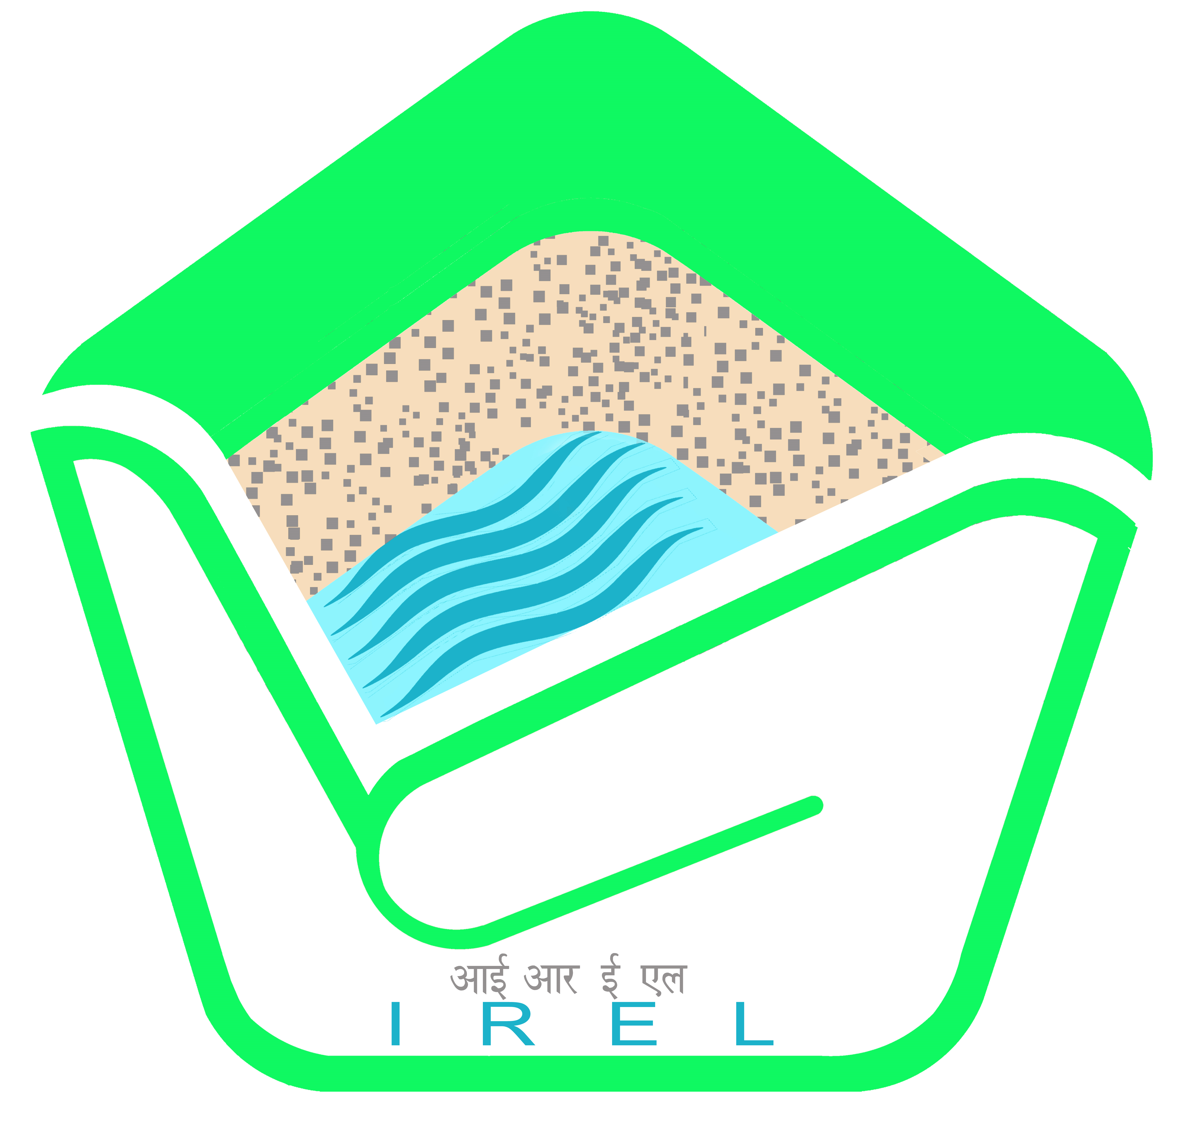  Unleashing Values   | आईआरईएल (इंडिया) लिमिटेड  IREL (India) Limited  (Formerly Indian Rare Earths Limited)  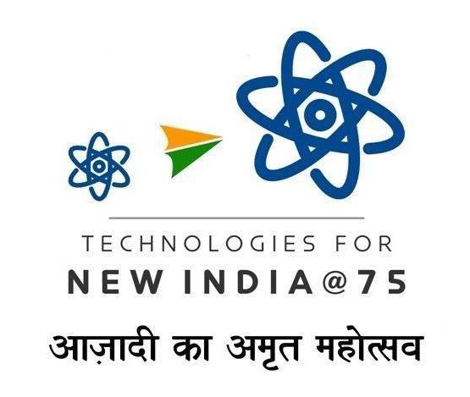  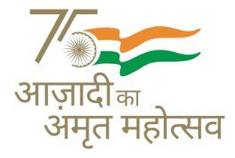  (भारत सरकार का उपक्रम)  (A Government of India Undertaking)  CIN : U15100MH1950GOI008187 Website : www.irel.co.in
ISO 9001: 2015, ISO 14001: 2015 & ISO 45001: 2018 Company

CORRIGENDUM- I Dated: 03/06/2025

Item/Job Description | Excavation Loading and transportation of raw sand from the different locations of Mining areas
GeM Bid No. | GEM/2025/B/6238349 Dated: 21-05-2025

Following Changes are hereby made in the tender:

Sl. No | Page no. | Clause | In Place of | To Read as
1 | 3/9 | Additional Qualification/Data Required  ↓  Terms and Conditions to be mentioned by Buyer for bidders to participate:1747805360.pdf  ↓  (Mentioned in Special Conditions of Contract under Clause no-24.0 (Pre Contract Integrity Pact) | 7. Independent Monitors  Shri Rais Ahmed  Mob. No. 9910007239  Mail:  ahmadrais1959@gmail.com | 7. Independent Monitors  (i)Dr.M. Malakondaiah,  156, Prashasan Nagar,  Jubilee Hills, Road No.72,  Hyderabad – 500110  M.No.9848031016/ 7330360888  Email:  mannam1958@gmail.com  (ii) Shri Lalit Chandra Trivedi  701, Premium Tower-IV,  Shalimar Township,  Indore-452010, (MP)  M.No.9967567679  Email:  Ictrivedi61@gmail.com

All other terms and conditions of the tender shall remain unchanged. Please visit us at http://irel.co.in & www.gem.gov.in for other details and further Corrigendum(s), if any.

Sd/-
DGM-T(Purchase)
-----------------------------------------------------------------------------------------------------------------

